Project Design Phase
Date | 25-06-25
Team Id | LTVIP2025TMID47835
Project Name | Resolver
Maximum Marks | 4 Marks
Solution Architecture
Solution Architecture:
The solution architecture for Resolve Now ensures a robust, user-friendly, and scalable
platform that connects clients with skilled freelancers. The architecture focuses on responsive
design, secure transactions, intelligent matching, and real-time messaging to ensure smooth
project workflows and high user satisfaction.
● Seamless Crime posting on the application
● End-to-end project lifecycle management
● Scalable user authentication and authorization
● Secure and trackable payment transactions
Example - Solution Architecture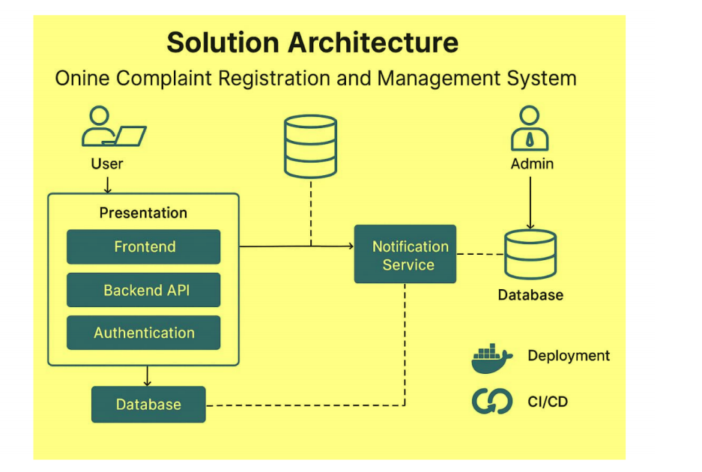e

